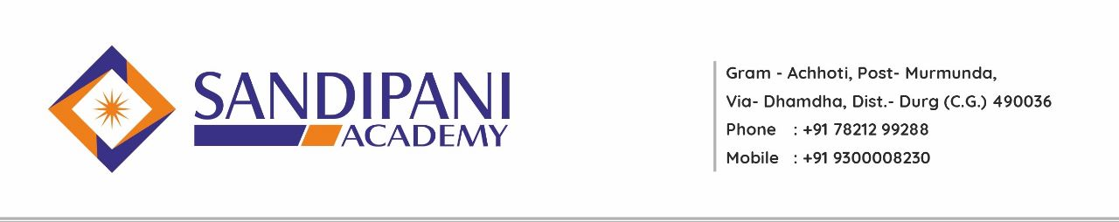
Academic Calendar
B. Ed III Semester
Session 2022-2023

Date: - 20/06/2022
Month | Activities Academic | Co-curricular Activities
July 2022 | Introduction of Syllabus  Commencement of Classes  Explanation of B.Ed III Semester Curriculum  One Unit of Each Subject including Pedagogical Subjects  Orientation lecture on school internship  Microteaching practice  Preparation of lesson plan | Assembly ( NEWS Reading, Thought of the Day)  Life skill program every Saturday  National Days Celebration  Guest Lecture
August  2022 | 1 Unit of Each Subjects  1 Unit of each Optional Pedagogical Subjects  Providing Assignment  School internship –3 months | Assembly ( NEWS Reading, Thought of the Day)  Life skill program every Saturday  National Days Celebration  Guest Lecture
September 2022 | School internship- 3 months | Assembly ( NEWS Reading, Thought of the Day)  Life skill program every Saturday  National Days Celebration  Guest Lecture
October 2022 | School internship- 3 months | Assembly ( NEWS Reading, Thought of the Day)  Life skill program every Saturday  National Days Celebration  Guest Lecture  Students Submission of Examination Forms
November 2022 | 2 Unit of each subjects including Pedagogical Subjects  School internship- 3 months  Lesson plan & reflective dairy submission  Remedial Class  Model Exam | Students Submission of Examination Form  Debates once on a month  New methodology of a teaching once in a week  Guest Lecture Submission of school internship file  During school internship experience shared by students
December 2022 | University semester examination

Note:
1) Discussion on School Education system.
2) Movie Review
3) Yoga / Meditation Saturday
4) Seminar by students
5) Language Lab for students

PRINCIPAL/H.O.D.

